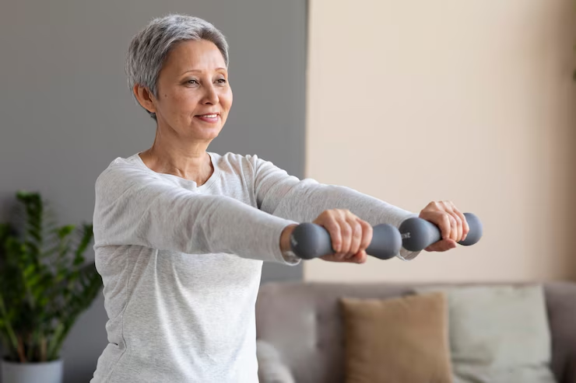

Image: [Freepik](https://www.freepik.com/free-photo/senior-woman-training-home_10847292.htm)

**Living Well, Aging Better: Practical Habits to Boost Your Body and Mind as a Senior**

There’s something deeply underrated about aging. We live in a world that treats youth as the finish line instead of the starting gun, which makes it easy to forget that the later chapters of life still belong to you. And while no one can sugarcoat the realities of aging—there are creaks, there are losses—there’s also this rare kind of clarity that shows up. You start asking better questions, like: What makes me feel good in my body? What actually lights me up? What do I want my days to feel like?

**Rethink Movement, Not Just Exercise**

The word “exercise” carries a lot of baggage—spandex, gym memberships, maybe a little guilt. But movement? Movement is yours. It’s the way your shoulders loosen after a slow walk or how your lungs open when you stretch first thing in the morning. You don’t have to measure steps or obsess over reps; just treat your body like a house you want to live in for a long time, and move around in it every day like you mean it.

**Stay Curious, Even When It's Inconvenient**

[Learning something new when you’re older](https://allseniorscare.com/blog/the-benefits-of-maintaining-a-curious-mind/) can be humbling, which is exactly why you should do it. Let yourself be the beginner who fumbles through a new recipe or stares blankly at a crossword clue for too long. That friction—however small—is like mental WD-40, keeping your brain limber and your pride in check. You don’t need to be great at it; you just need to care enough to try.

**Try Meditation**

There’s something deeply grounding about sitting still on purpose, even if the world around you is anything but. Meditation isn’t about clearing your mind or achieving inner peace on demand—it’s about giving yourself permission to notice what’s going on inside without judgment. When you carve out just 10 to 20 minutes each day to [sit quietly and observe your breath](https://www.zenbusiness.com/blog/living-a-healthier-lifestyle-with-smarter-choices/), you create a buffer between yourself and the chaos, a little mental room to breathe.

**Eat Like You Love Yourself**

Forget the long list of “don’ts.” Let’s talk about how food actually makes you feel. Maybe you’ve noticed that greasy dinners mess with your sleep, or too much sugar [throws off your mood](https://www.bbcgoodfood.com/health/wellness/how-does-sugar-affect-mood). Start tuning in—not obsessively, but intentionally—and you’ll start making choices that serve both your taste buds and your future self. Think nourishing, not restricting; think cozy, not complicated.

**Make a Habit of Saying Hello**

You don’t have to be a social butterfly to stay connected. In fact, some of the most sustaining interactions are small and regular—a nod to your neighbor, a shared laugh with the pharmacist, a quick check-in with someone you care about. These aren’t throwaway moments; they’re lifelines. In a time when [loneliness quietly chips away at](https://www.pbs.org/newshour/health/how-the-loneliness-of-social-isolation-can-affect-older-adults-brains) health, reaching out (even just a little) can be the most radical thing you do.

**Turn Sleep Into a Ritual, Not a Routine**

Sleep doesn’t come easy for everyone, especially as you get older. But instead of treating it like an elusive goal, try approaching it like an art form. Dim the lights early, stop scrolling through your phone, and let your bedroom become the quietest place in your life. Some nights will still be restless—that’s okay. But giving yourself the [chance to truly wind down](https://thekey.com/learning-center/improving-sleep-in-older-adults) tells your nervous system, in no uncertain terms, that you’re safe.

**Redefine What a “Productive Day” Looks Like**

You’re allowed to slow down. In fact, you’ve earned it. The culture might whisper otherwise—push harder, fill your calendar, stay “useful”—but the truth is, rest is useful. A walk with no destination, a slow morning with your favorite mug, [time spent doing absolutely nothing](https://www.henryford.com/blog/2022/12/6-health-benefits-of-taking-time-to-do-nothing): this is where your nervous system catches up to your soul. Let that be enough.

**Pay Attention to the Subtle Stuff**

Your body’s always talking—you just have to start listening before it starts shouting. Maybe your joints feel tight when the weather shifts, or maybe certain foods just don’t sit right anymore. Don’t brush those signals off like background noise. They’re not just quirks of aging; they’re invitations to adjust, recalibrate, and stay ahead of the curve.

The real gift of growing older isn’t wisdom, though there’s plenty of that. It’s the freedom to decide what you want your life to feel like now. You don’t have to chase youth, and you don’t have to settle for decline—you just have to keep choosing to show up. And when you do, day by day, with intention and care, you’ll find that there’s more energy, more joy, and more depth than you ever expected.

***Navigate the complexities of Medicare with ease by visiting*** [***Medicare Resources USA***](https://medicareresourcesusa.com) ***for expert guidance and personalized support, all at no cost to you!***